Date: 22.11.2024 Priscilla G  
 ACE12438

Git and Github Task   
 Push Commands  
  
Create new repository

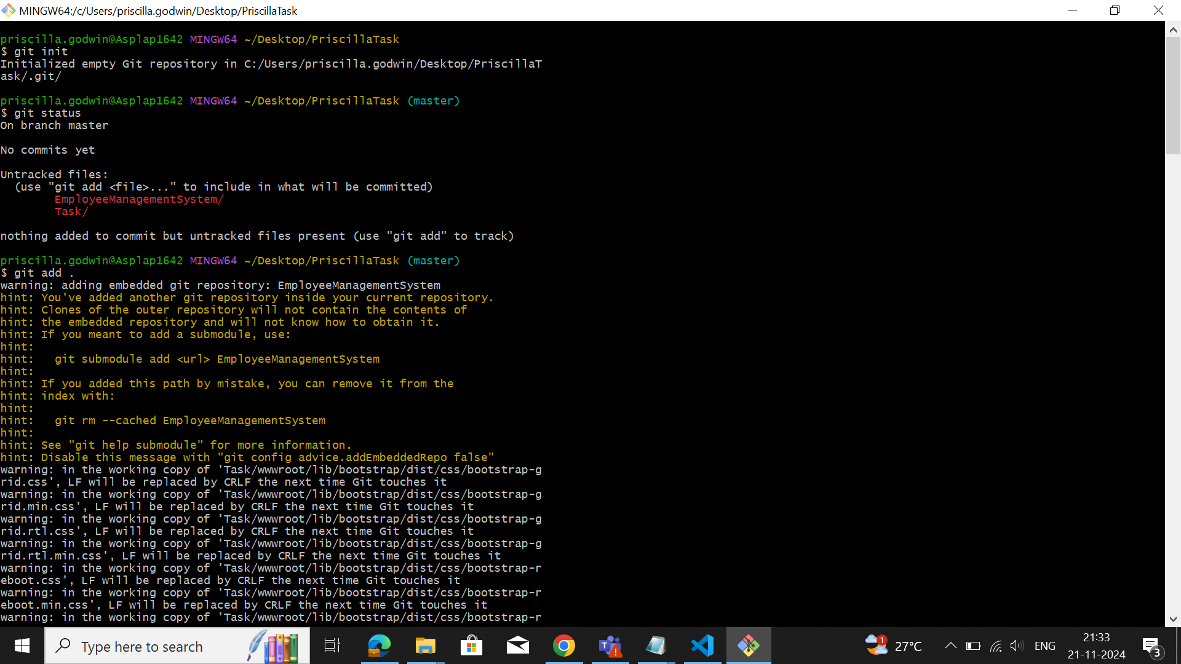

Initialize the git  
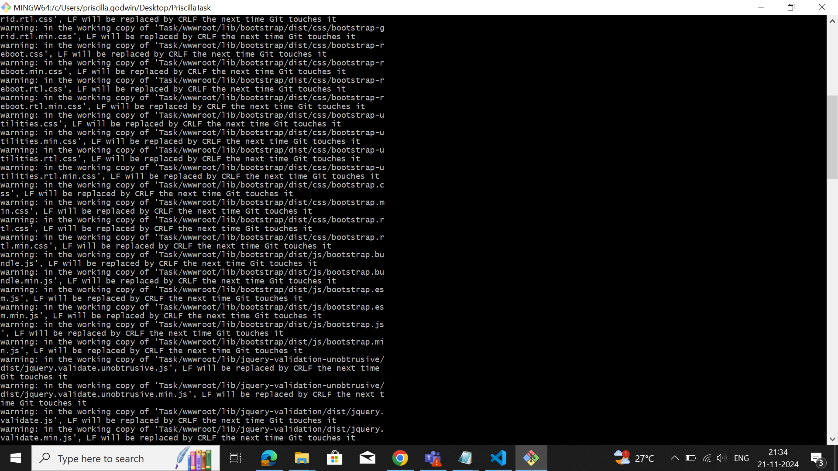Stagging area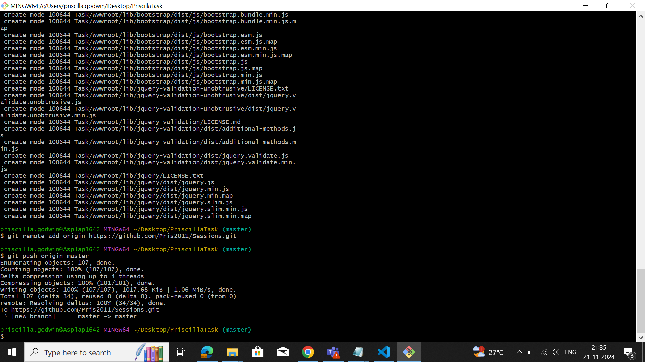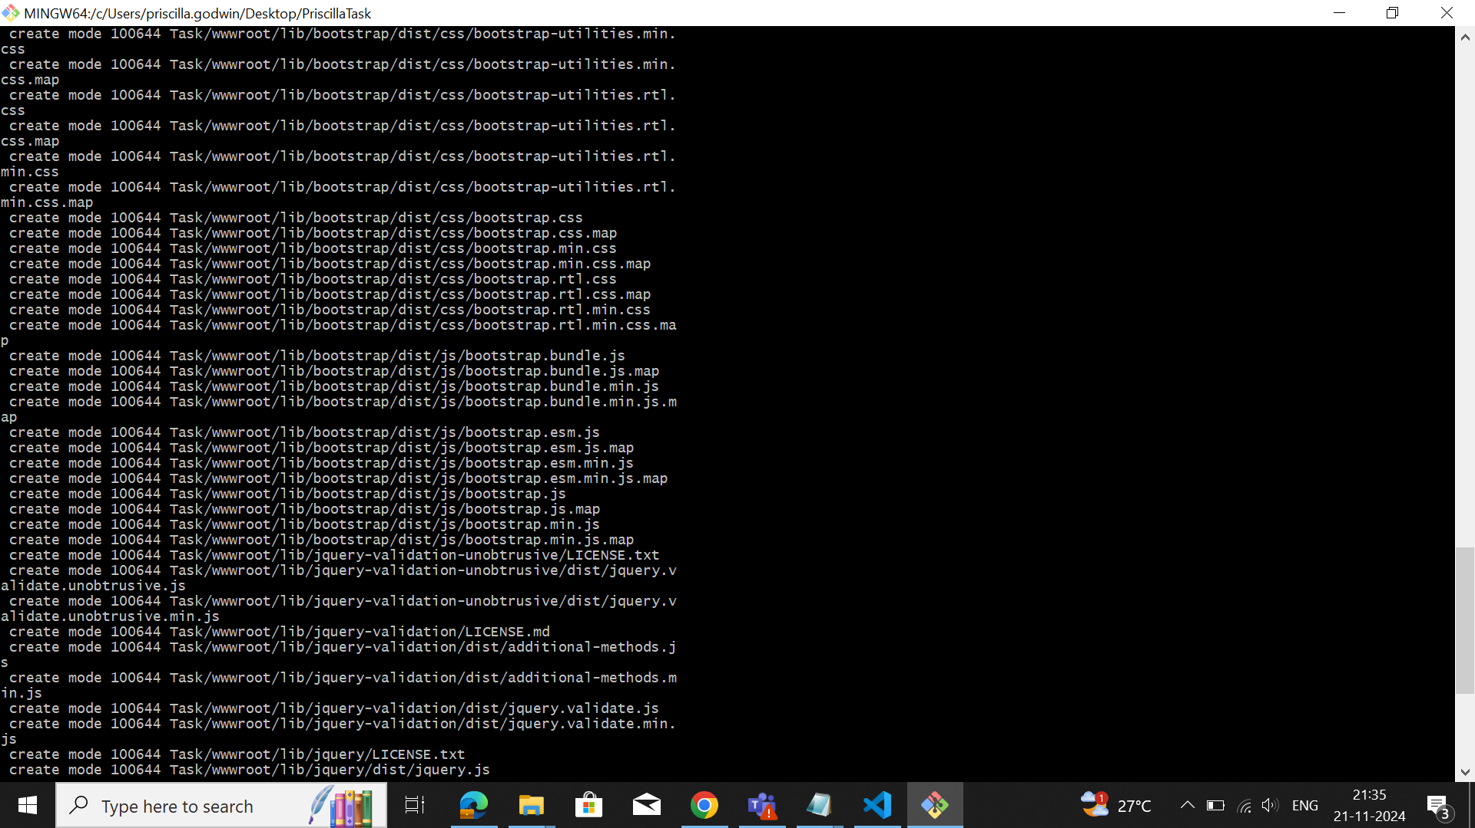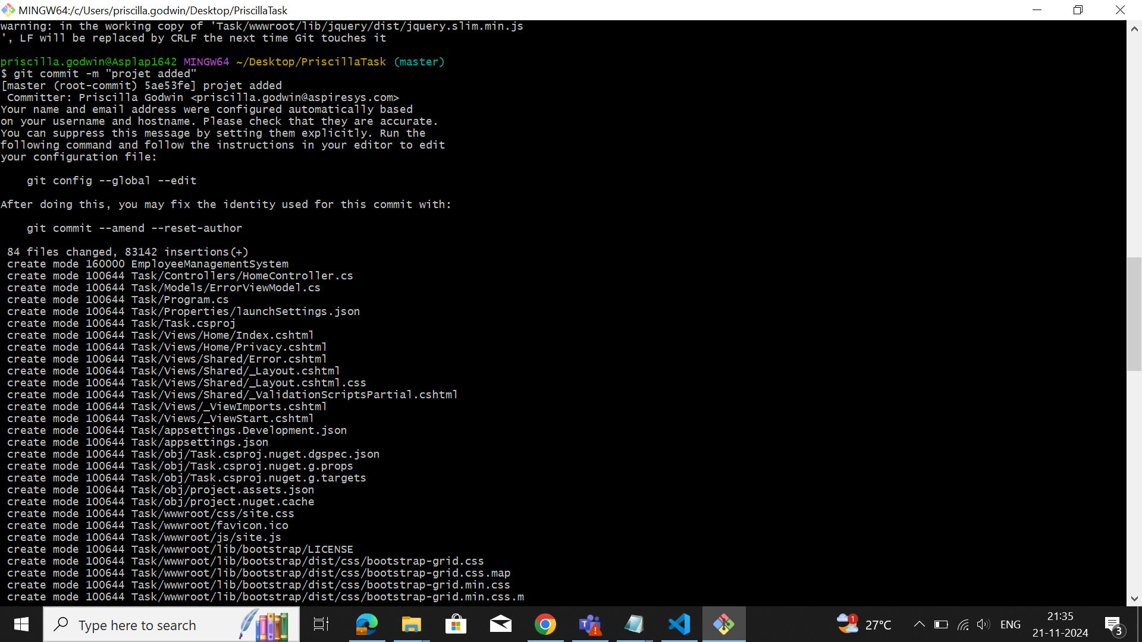Commit to local repository and pushing to remote repository